**Your Name: Partner’s Name:**

**IST 772 Week 10 Class Exercise**: **Interactions in Multiple Regression Continued**

As a reminder, this dataset contains 50 observations, n=25 from the U.S. (GRP==1) and n=25 from Canada (GRP==2). Each research participant provided a star rating (from 1 to 5 stars) of one brand of earbuds, while listening to a brief musical selection. Each participant provided a self-rating **(IV1)** of on a 10-point scale (1=not at all, 10=totally) on whether they were a music enthusiast. Each participant also took a test of audiophile knowledge **(IV2)** with 20 true-false questions, where the score shows the number of correct responses for each person. (An audiophile is a person who loves listening to high-quality sound from a stereo or home theater.)

**Interpreting the Interaction**: Now you will break open the model to see how the interaction works.

1. Create two separate data sets, doing a median split on IV2, audiophile knowledge. ProductEval$HI2 <- ProductEval$IV2 > median(ProductEval$IV2)

hiData <- ProductEval[ProductEval$HI2==TRUE,]

loData <- ProductEval[ProductEval$HI2==FALSE,]

**What exactly are these lines of code accomplishing?**

The code is splitting the "ProductEval" data frame into two subsets based on the median value of "IV2". The "hiData" data frame contains all rows with values of "IV2" above the median, and the "loData" data frame contains all rows with values of "IV2" below or equal to the median.

1. Run **two separate** simple regression models, one using hiData and one using loData, where IV1 predicts DV. **Report the results.**

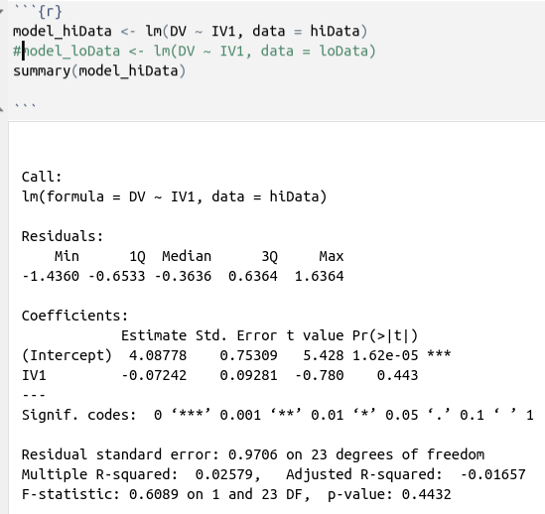

The "t value" and "Pr(>|t|)" columns show the results of hypothesis testing for the significance of each coefficient. In this case, the intercept is significantly different from zero with a p-value of 1.62e-05 (less than 0.05), while the coefficient for IV1 is not significant with a p-value of 0.443 (greater than 0.05).

The "Residual standard error" is an estimate of the standard deviation of the errors of the model, and the "F-statistic" and "p-value" columns show the overall significance of the model. In this case, the F-statistic is not significant with a p-value of 0.4432.

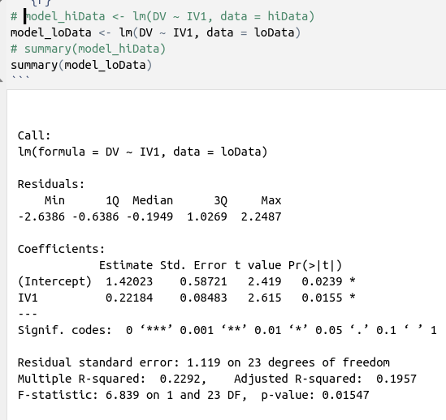

The output shows the estimates for the intercept and slope coefficients of the linear regression model. The intercept estimate is 1.42023 and the slope estimate for IV1 is 0.22184. The p-values for both the intercept and slope coefficients indicate that they are statistically significant at the alpha level of 0.05, meaning that there is evidence to suggest that both variables are related to the outcome variable.

The "F-statistic" tests the overall significance of the model, and its associated p-value suggests that the model is statistically significant as a whole at the alpha level of 0.05.

1. Create a scatterplot of IV1 versus DV. Then use abline() with the reg= option to plot a different colored regression line for the two different models from the previous step. **Paste a copy here.**

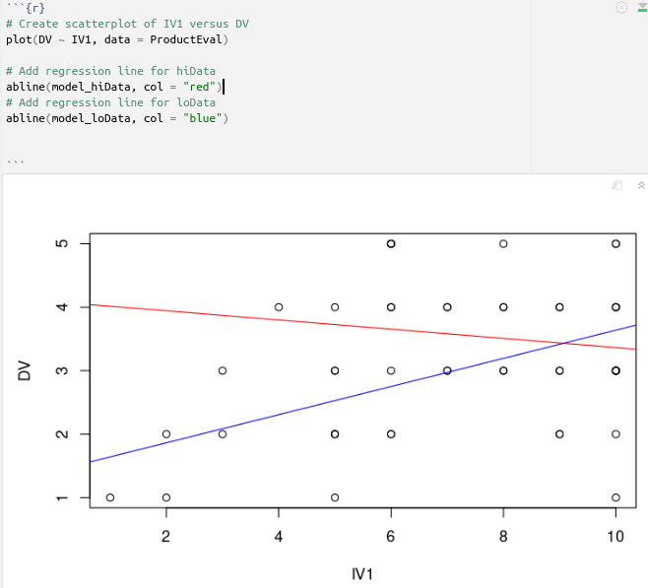

1. Using all the evidence you have, **interpret the overall results of the study. What rater characteristics relate to more stable ratings of a product?**

The results show that the more stable ratings of a product are the ones in "hiData" data frame which contains all rows with values of "IV2" above the median. It means that they have more knowledge about the music, and they are rating the products better than the ones in loData.

**Examination of Country of Residence**: So far, we have not included GRP in any of our analysis.

1. Run t-tests using GRP as the grouping variable. **Examine and interpret mean differences on DV, IV1, and IV2. Are U.S. and Canadian raters different?**

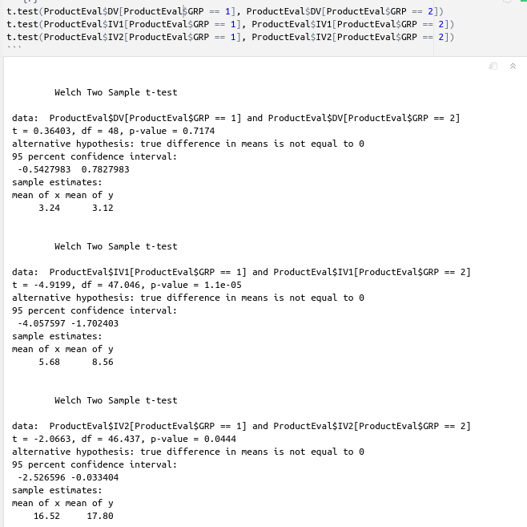

1. Create a simple linear (main) effects only regression model predicting DV from IV1 (centered), IV2 (centered), and GRP. **Should GRP be centered before doing the analysis?** **Interpret the results.**
2. Create a model predicting DV from the interaction (between IV1centered and IV2 centered) and GRP. **Interpret the results.**